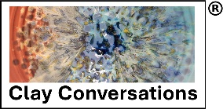
Founder: Dr Lynne Souter-Anderson
www.clayconversations.org

Practitioner Award in Clay Conversations – Level 5 (RQF), Application Form

Date of course applying for:

Name:

Address:

Date of birth:

Phone No: Email

Current occupation:

Please share your experiences of using clay in whatever capacity:

Please share your experiences of helping/supporting others in aspects of well-being:

What appeals to you about the Award?

What do you hope to do upon successfully completing this Award?

Name, Contact details and address of someone who will provide a reference on your suitability for the Practitioner Award in Clay Conversations.

Signed: Date:

Please send completed application form to: lynne@bctconsultancy.co.uk

